Asteroids (1979, arcade), Atari. GAMEPLAY MODE

1. Composition
Tangible space | Fullscreen.
Intangible space | None.
Negative Space | None.
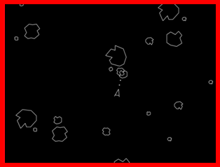
External | Zero-Ergodic
2. Ocularization

3. Framing mechanisms | Anchor : Objective | Mobility : Fixed

4. Plane Analysis
 | Agents | In-game | Off-game
Graphical materials | Vector graphics | - | -
Projection method | Orthogonal | - | -
Angle of projection | Top-Down | - | -

Notes :
A simple and flowing action game, Asteroids exemplifies the uniformity of early video games’ visuality. The player’s agent is taking a central but very small part of the space around it. This already creates a rhythm in the reading of the screen as a back and forth between the endangered agent and potential dangers. Control feels relative to a specific skillset that is already evident when looking at the screen: assess the urgency of obstacles and react accordingly from instant to instant.
Asteroids has nothing to show but the agents it sets in motion: pure tangibility with little to no mimetism.
